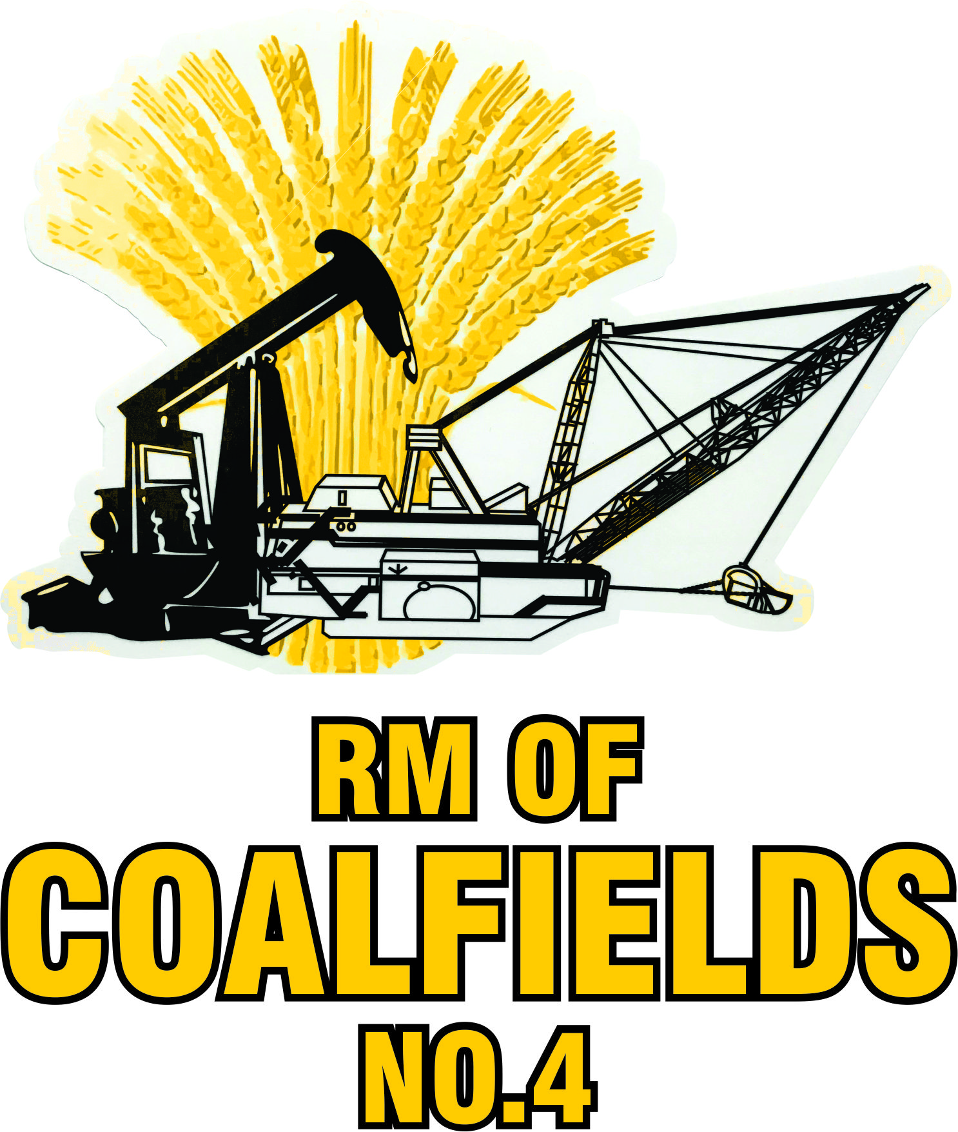

FORM H
[Section 66 of the Act]

Notice of Call for Nominations
Municipal Elections

PUBLIC NOTICE is hereby given that nominations of candidates for the offices of:

Councillor: Rural Municipality of Coalfields No. 4 – Division 3

will be received by the undersigned on the 22nd day of September, 2021, from 8:30 a.m. to 4:00 p.m. at The Rural Municipality of Coalfields No. 4 Office, 423 Main Street, Bienfait, and during regular business hours on September 1st to September 21st, 2021, at The Rural Municipality of Coalfields No. 4 Office, 423 Main Street, Bienfait.

Nomination forms may be obtained at the following location:

The Rural Municipality of Coalfields No. 4 Office
423 Main Street
Bienfait, Saskatchewan

Dated this 1st day of September, 2021.

Holley Odgers—Returning Officer

